
Liu Deqin, Professor, vice director of the institute of cartography and GIS in Chinese Academy of surveying and Mapping. The recent research topic is theory, establishment and application of Census GIS.

ANALYSIS OF SOCIAL SPATIAL STRUCTURE OF POOR POPULATION
Liu Deqin, Liu Yu, Ma Weijun
Chinese Academy of Surveying and Mapping,
Beijing 100039, China
liudq@casm.ac.cn
Abstract: Social spatial structure is the geo-spatial representation of the process in population development and it reflects the spatial distribution rule of social and economic attributes of population. Social spatial structure in the rural area with large poor population is analyzed. The characteristic, rule and difference in the area are found out. The result can be used for the government to form the policy to collocate the resource, harmonize the population and environment and realize the sustainable development.

1 INTRODUCTION

Social spatial structure of population is the geo-spatial representation of the process in population development and it reflects the spatial distribution rule of social and economic attributes of population. Social spatial structure of population generally indicates spatial relationship of differentiation and organization in social, economic and resource aspect of population^{[1]}. It can reflect the harmony and collocation relationship between population and society, economy, resource, environment, and development differentiation in a large area. In the rural area with large poor population, understanding of its spatial distribution can help the government form the policy to collocate the resource, harmonize the population and environment and realize the sustainable development. The factors of social spatial structure of population are complicated. The study of social spatial structure of poor population in different period can help to understand the progress and new situation of poor alleviation and provide the reference to adjust the strategy for poor alleviation.

The previous study of social spatial structure of population is mainly focus on the urban area. As early as 1950s, many foreign scholars have done much research in social spatial structure in urban area to indicate the rule of distribution of social spatial structure in some city in Europe and American, using the factorial ecological analysis^{[2][3]}. Xu Xueqian, etc. studied the social spatial structure of Guangzhou city by factorial ecological analysis and cluster analysis (WARD method), obtained the principal components forming the type of social district and indicated spatial pattern of the city and mechanism forming the spatial pattern ^{[4]}. Zhu Junming analyzed the social spatial structure of population in downtown area in Shanghai by the use of population census data ^{[5]}. Liu Haiyong analyzed the social spatial structure of migrant population in China, Yunnan Province and Beijing city ^{[6]}.

2 METHOD

2.1 Data source
The spatial unit is based on the village. The data of poor-alleviation village is from the “Information Network of Poor Alleviation in Heilongjiang Province” 【http://218.7.20.23/index.jsp】. The data is updated and entirely reflect the population status, natural resource, social fundamental condition and economic condition in the poor villages. Four classes and 22 variables are used for the study (details are shown in table 2).

2.2 Method
Many scholars use the multivariable statistic analysis to find the relationship between population and social and economic element. Some methods are affected by subjective factors. For the objectively analyzing the relationship between population and social and economic element, the PCA (Principal Component Analysis) is used to analyze the original variables related to population attributes. New comprehensively independent variables are created for the further study for the social spatial structure of the studied area.

The analysis steps are as follows:
- Standardization of original variables. Standardization formula:
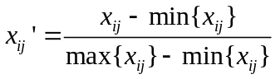，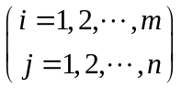
- Calculation of correlation coefficient matrix R.
- Calculation of eigenvalue and eigenvetor based on the eigen equation 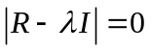.
- Calculation of contribution rate, cumulative contribution rate and principal component.
- Calculation of load matrix of principal component factor.
- Calculation of principal component score and obtaining score matrix.
- Analysis of result.

3 example

The study area is selected in Heilongjiang Province in north east China, including 646 poor alleviation administrative villages in five city (Jiamusi city, Hegang city, Shuangyashan city, Qitaihe city and Jixi city) as shown in Figure 1.
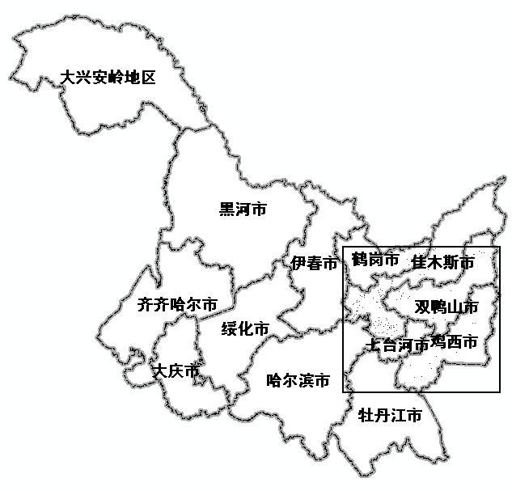
Figure 1 Study area in Heilongjiang Province

The result obtained from Principal Component Analysis of 22 variables across 646 villages shows the most important four principal components. The eigenvalue of each principal component is larger than 2 and they together account for more than 53 percent of total variance (as shown in Table 1).

Table 1 Eigenvalue and Variance Contribution Rate of Each Principal Component
Principal component | 1 | 2 | 3 | 4 | 5 | 6 | 7 | 8 | 9 | 10 | 11 | 12
eigenvalue | 5.423 | 4.616 | 3.943 | 2.519 | 1.365 | 1.256 | 1.189 | 1.018 | 0.939 | 0.843 | 0.791 | 0.780
Contribution rate | 25.5573 | 11.8918 | 8.8300 | 6.9036 | 5.2036 | 4.7082 | 4.4023 | 3.6264 | 3.2682 | 2.8300 | 2.5955 | 2.5432
Cumulative variance contribution rate | 25.557 | 37.449 | 46.279 | 53.183 | 58.386 | 63.095 | 67.497 | 71.123 | 74.391 | 77.221 | 79.817 | 82.360

Table 2 Revolved Principal Component Load Matrix
Variable Characteristics | Variable No. | Variable Name | Principal Component
Variable Characteristics | Variable No. | Variable Name | F1 | F2 | F3 | F4
Population | X1 | Population density | -0.2910 | 0.0254 | -0.0529 | 0.0372
Population | X2 | Population per household | -0.1936 | 0.0378 | 0.2166 | 0.0264
Population | X3 | Ratio of poor population to total | 0.3871 | 0.0221 | -0.2860 | -0.1239
Population | X4 | Ratio of Poor labor population to total | 0.3869 | 0.0612 | -0.2347 | -0.1449
Resource | X5 | Area of glebe per person | 0.3751 | 0.0129 | 0.1376 | -0.0097
Resource | X6 | Area of paddy field per person | 0.0981 | -0.0936 | -0.1759 | 0.0265
Resource | X7 | Area of woodland per person | 0.2026 | -0.0253 | 0.0705 | -0.2385
Resource | X8 | Area of meadow per person | 0.2658 | 0.0164 | 0.1035 | -0.1708
Fundamental Social condition | X9 | Number of telephone per 100 household | -0.0104 | -0.4131 | 0.0531 | -0.0581
Fundamental Social condition | X10 | Number of cable television per 100 household | 0.1215 | -0.3013 | -0.0639 | -0.0352
Fundamental Social condition | X11 | Number of preliminary school per 1000 person | 0.2251 | -0.0790 | 0.2261 | 0.1028
Fundamental Social condition | X12 | Number of medical institution per 1000 person | -0.0392 | -0.1716 | 0.1901 | 0.1409
Fundamental Social condition | X13 | Ratio of number of brick houses to total | -0.1568 | -0.4723 | -0.2269 | 0.0320
Fundamental Social condition | X14 | Ratio of number of thatched cottage to total | 0.1568 | 0.4723 | 0.2271 | -0.0320
Fundamental Social condition | X15 | Number of large and medium size tractor per 100 household | 0.2640 | -0.1447 | 0.1779 | -0.0138
Fundamental Social condition | X16 | Number of small size tractor per 100 household | 0.2121 | -0.3282 | 0.1347 | 0.1192
Economic situation | X17 | Amount of food occupancy per person | 0.2149 | -0.1454 | -0.2388 | 0.1241
Economic situation | X18 | Income of stock raising per person | -0.0614 | -0.1427 | 0.4208 | -0.3234
Economic situation | X19 | Income of avocation per person | -0.0274 | -0.1327 | 0.3863 | -0.4092
Economic situation | X20 | Income of service per person | -0.0585 | -0.1939 | 0.0314 | -0.1179
Economic situation | X21 | Debt per person | 0.1544 | 0.0542 | 0.0280 | 0.5055
Economic situation | X22 | Creditor’s right per person | 0.0901 | -0.1136 | 0.0450 | 0.5161

4 result ANALYSES

The meaning of principal components is determined based on the principal component load matrix and the influence of principal component to social economic structure of population is analyzed by the score of principal component in 646 villages.

4.1 The first principal component – poverty aspect
The eigenvalue of the first principal component is 5.423 and Cumulative variance contribution rate is 25.557. It is the main factor for the differentiation of spatial distribution of poor population in the study area. Based on the load matrix of principal component, the first principal component is largely related to 6 variables, which has positive correlation with ratio of poor population to total, ratio of poor labor population to total, area of glebe per person, area of meadow per person, number of large and medium size tractor per 100 household and has negative correlation with population density.

The score of the first principal component is shown as Figure 2 (the darker the dot, the higher the score). The area with higher score is concentrated on the north part, such as Suibin county and Yaohe county, and has the trend of lower score to the south, such as Qitaihe city and Jixi city.

4.2 The second principal component – production and living condition
The eigenvalue of the second principal component is 4.616 and Cumulative variance contribution rate is 11.8918. Based on the load matrix of principal component, the second principal component is strongly related to variable of ratio of number of thatched cottage tototal, and has negative correlation with ratio of number of brick houses to total, number of telephone per 100 household, number of small size tractor per 100 household, and number of cable television per 100 household. It mainly reflects the production and living condition in the study area.

The score of the second principal component is shown as Figure 3 (the darker the dot, the higher the score). The area with higher score is concentrated on the some country, such as Suibin county, Yaohe county, Huachuan county and Jixuan county. The Jiamusi city and Tangyuan county have the lower score.

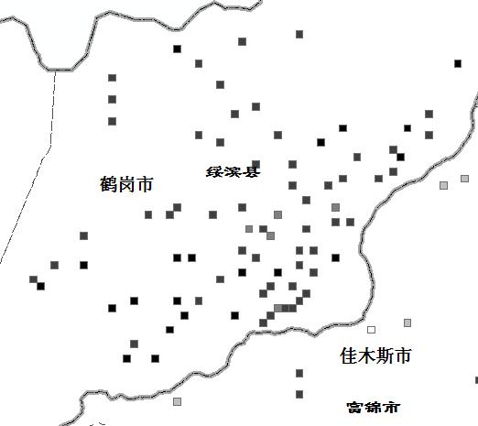
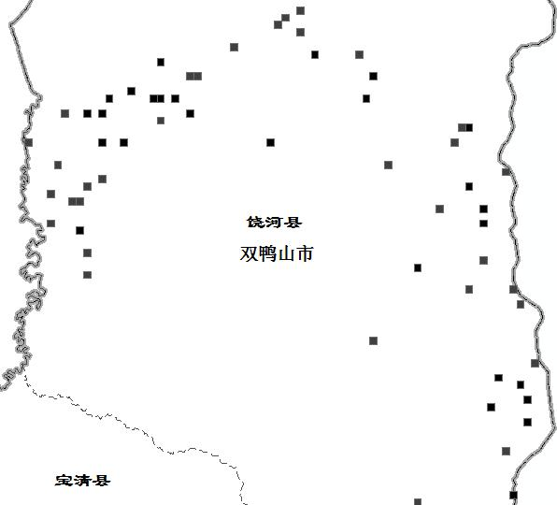

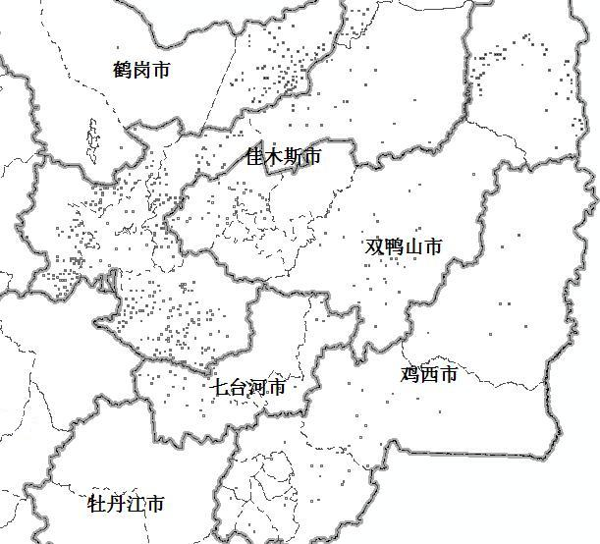
Figure 2 The first principal component – poverty aspect

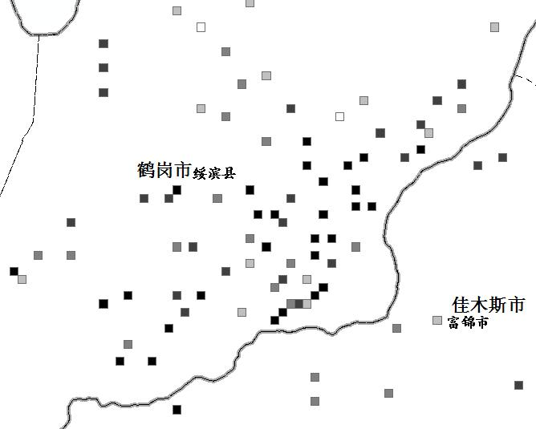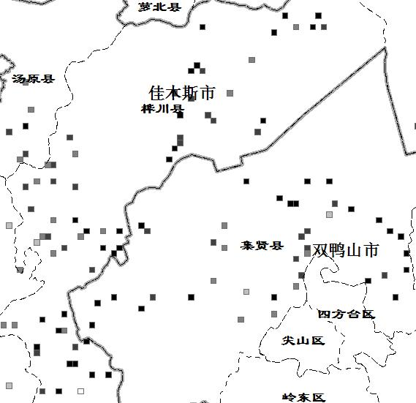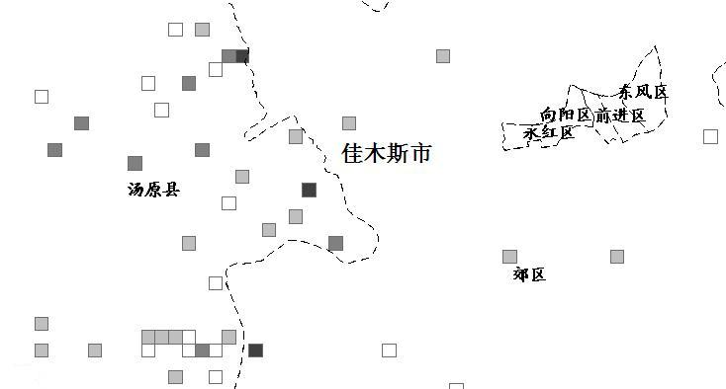
Figure 3 The second principal component – production and living condition

4.3 The third principal component – income
The eigenvalue of the third principal component is 3.943 and Cumulative variance contribution rate is 8.83. Based on the load matrix of principal component, the third principal component has positive correlation with income of stock raising per person and income of avocation per person and has negative correlation with amount of food occupancy per person and ratio of poor population to total. It mainly reflects the total income in these villages.

The score of the third principal component is shown as Figure 4 (the darker the dot, the higher the score). The area with higher score is concentrated on the major poor-alleviation villages, such as in Jixi city, Jidong county Mishan county, Fulin county and Baoqin county.
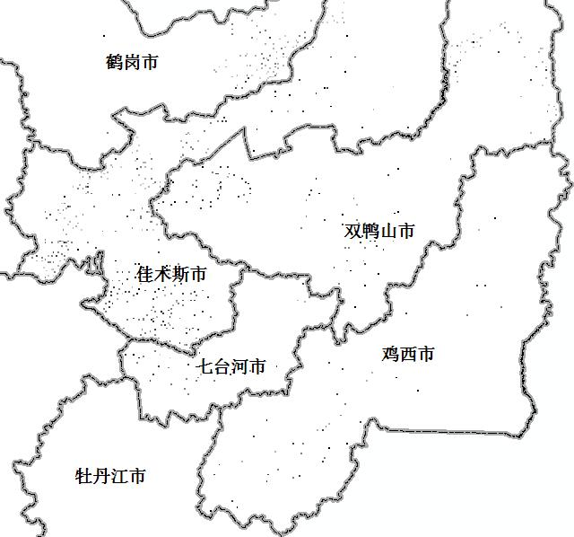
Figure 4 The third principal component – income

4.4 The fourth principal component – collective economy
The eigenvalue of the fourth principal component is 2.519 and Cumulative variance contribution rate is 6.9036. Based on the load matrix of principal component, the fourth principal component is strongly related to variable of debt per person and creditor’s right per person, and has negative correlation with income of stock raising per person, income of avocation per person and area of woodland per person. It mainly reflects the collective economy in the study area.

The score of the fourth principal component is shown as Figure 5 (the darker the dot, the higher the score). The spatial distribution of area with higher score does not show any obvious rule in the study area. It means that every poor-alleviation villages in any county have poor condition of collective economy.
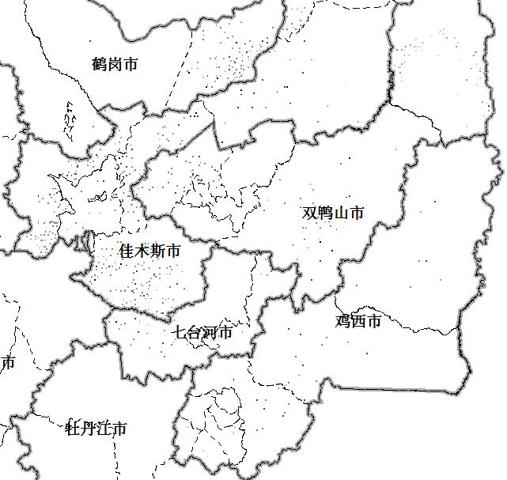

Figure 5 The fourth principal component – collective economy
5 conclusionS

From the principal component analysis, the factors which influence the social spatial structure of poor population in the study area are farmland fundamental construction, structure of agriculture industry and rural collective economy. The first principal component shows that the poverty aspect has strongly positive relation with area of glebe per person. It means that we must pay attention to farmland reconstruction of glebe to advance the condition of farmland usage for farm product. The third principal component shows that stock raising and avocation have pay an important role in the poor alleviation, but the income is still at the low level and service income is only the small part in the income structure. The fourth principal component shows village collective economy is not in a good condition and the debt is another problem in the poor alleviation process. Some advices are given as follow:
(1) Strengthening farmland fundamental construction, building some establishment of irrigation works, improving the condition of glebe, to make the farmland not only suitable for food but also suitable for other crop
(2) Development of agriculture economy and improvement of production and living condition
(3) In the precondition of ensuring stable food production, encouragement of transforming agriculture labor to other industry and adjustment of crop planting structure, increasing the channel of income.
(4) Adjustment measures to local conditions for the development of collective economy in the poverty area, forming a reasonable structure of creditor’s right and debt, promoting the sustainable development of rural economy.

6 REFERENCES
[1] Zhang shanyu. Concept of population geography. East China Normal University Press, 1999, 265-266
[2] Ley D..A social geography of the city. New York: Harper & Row publishers， 1983，55-95
[3] David T Herbert, Collin J Thomas. Urban Geography: a first approach. Chicester: John Wiley & Sons，1982，263-334
[4] Xu xueqiang, etc. Factorial ecological analysis of social spatial structure in Guangzhou city. Geography Transaction, 1989, 44(4), 385-396
[5] Zhu junming. Social spatial analysis of population in Shanghai. Science of Chinese Population, 1995,49(4), 21-30
[6] Liu haiyong, etc. Configuration, structure and function of floating population in Beijing. Geography Science, 1999,19(6), 497-503

